**DIGITAL ASSESSMENT – 2**

**16BCE0789**

**Om Ashish Mishra**

**The Question:**

Using proper data base tables implement the banking system in Java.

**The Description:**

**I have assumed that a bank maintains two kinds of accounts for customers, one called as savings account and the other as current account. The savings account provides compound interest and withdrawal facilities but no cheque book facility. The current account provides cheque book facility but no interest. Current account holders should maintain a minimum balance and if the balance falls below this level, a service charge is imposed. Create a class account that stores customer name, account number and type of account. From this derive the classes cur_acct and sav_acct to make them more specific to their requirements. Include necessary member functions in order to achieve the following tasks :**

**CODE:**

# /*===============================================================*/ //@Class Account

**import** java.util.Scanner;

**public** **class** Account {

**protected** Scanner scan; **protected** String customerName; **protected** String accountType; **protected** **int** accountNumber; **protected** **double** balance; **protected** **double** interestRate, serviceCharge, minimum;

**public** **void** openAccount(String accountType, **double** minimum,

**double** serviceCharge, **double** interestRate) {

**this**.minimum = minimum; **this**.serviceCharge = serviceCharge; **this**.interestRate = interestRate; **this**.accountType = accountType;

scan = **new** Scanner(System.***in***);

System.***out***.print("\nEnter customer name : "); **this**.customerName = scan.nextLine(); System.***out***.print("Enter account number : "); **this**.accountNumber = scan.nextInt();

System.***out***.print("Enter opening balance : "); **this**.balance = scan.nextDouble();

System.***out***.println("Account created!!\n");

} **public** **int** getAccountNumber() {

**return** accountNumber;

}

**public** **void** withdraw() {

scan = **new** Scanner(System.***in***);

System.***out***.print("\nEnter amount to withdraw : "); **double** withdrawAmount = scan.nextDouble();

**if** (balance > withdrawAmount) {

balance -= withdrawAmount;

System.***out***.println("Rs. " + withdrawAmount + " withdrawal from your account\n"

+ "Your current balance : " + balance);

**if** (balance < minimum) {

System.***out***.println("Information : Your current balance is less than minimum balance amount (Rs. " + minimum + ")");

}

} **else** {

System.***out***.println("Sorry you don't have sufficient balance!!");

}

} **public** **void** deposit() {

scan = **new** Scanner(System.***in***);

System.***out***.print("\nEnter amount to be deposite : "); **this**.balance += scan.nextDouble();

System.***out***.println("\nAmount deposited!!");

}

**public** **void** display() {

scan = **new** Scanner(System.***in***);

System.***out***.println("Customer name : " + customerName);

System.***out***.println("Account type : " + accountType);

System.***out***.println("Account number : " + accountNumber);

System.***out***.println("Balance : " + balance);

}

}

# /*===============================================================*/ //@ Class Cur_acct

**import** java.util.Scanner;

**public** **class** Cur_acct **extends** Account {

**public** **void** issueCheque() { scan = **new** Scanner(System.***in***);

System.***out***.print("\nEnter amount : "); **double** amount = scan.nextDouble();

System.***out***.println("Cheque issued for Rs. " + amount);

}

**public** **void** checkBal() {

scan = **new** Scanner(System.***in***);

**if** (balance < minimum) {

balance -= serviceCharge;

System.***out***.println("Your current balance is less than minimum balance amount (Rs. " + minimum + ")"

+ " your account is discharged by Rs. " + serviceCharge); } **else** {

System.***out***.println("Everything is good!!");

}

}

}

# /*===============================================================*/ //@Class Sav_acct

**import** java.util.Scanner;

**public** **class** Sav_acct **extends** Account {

**public** **void** interest() {

**double** interest = (balance * interestRate) / 12; System.***out***.println("Calculated interest : " + interest);

scan = **new** Scanner(System.***in***);

System.***out***.print("Do you want to update balance [y/n] : ");

**if** (scan.nextLine().toLowerCase().equals("y")) {

balance += interest;

System.***out***.println("Interest of Rs. " + interest + " is added to your account!!");

System.***out***.println("Your current balance : " + balance); }

}

}

# /*===============================================================*/ //@Class Main

**import** java.util.ArrayList; **import**

java.util.Scanner;

**public** **class** Main {

**public** **static** Account searchAccount(ArrayList<Account> accounts)

{

Scanner scan = **new** Scanner(System.***in***); System.***out***.print("Enter account number : "); **int** accountNumber = scan.nextInt(); **for**

(Account tmpAccount : accounts) { **if** (tmpAccount.getAccountNumber() == accountNumber) {

**return** tmpAccount;

} }

**return** **null**;

}

@SuppressWarnings("resource") **public** **static** **void** main(String[] args) {

ArrayList<Account> accounts = **new** ArrayList<Account>();

Scanner scan;

**double** interestRate = 0.15, serviceCharge = 100,

minimum = 500;

**while** (**true**) {

scan = **new** Scanner(System.***in***);

System.***out***.println("Open account [1]");

System.***out***.println("Deposite [2]");

System.***out***.println("Withdraw [3]");

System.***out***.println("Interest [4]");

System.***out***.println("Issue cheque [5]");

System.***out***.println("Check for minimum balance [6]");

System.***out***.println("Display account [7]");

System.***out***.println("Exit [8]");

System.***out***.print(">> ");

**int** option = scan.nextInt();

scan = **new** Scanner(System.***in***);

**switch** (option) {

**case** 1:

System.***out***.print("\nEnter account type [sav / cur] : ");

String accountType = scan.nextLine(); Account account = accountType.equals("sav") ? **new** Sav_acct() : **new** Cur_acct();

account.openAccount(accountType, minimum,

serviceCharge, interestRate); accounts.add(account);

**break**; **case** 2:

Account search = Main.*searchAccount*(accounts);

**if** (search == **null**) {

System.***out***.println("Sorry account not found!!");

} **else** { search.deposit(); } **break**;

**case** 3: search =

## Main.searchAccount(accounts);

**if** (search == **null**) {

System.***out***.println("Sorry account not found!!");

} **else** { search.withdraw(); } **break**;

**case** 4: search =

## Main.searchAccount(accounts);

**if** (search == **null**) {

System.***out***.println("Sorry account not found!!");

} **else** **if** (search **instanceof** Sav_acct) {

((Sav_acct) search).interest();

} **else** {

System.***out***.println("Account type is not valid!!");

} **break**; **case** 5: search = Main.*searchAccount*(accounts); **if** (search == **null**) {

System.***out***.println("Sorry account not found!!");

} **else** **if** (search **instanceof** Cur_acct) {

((Cur_acct) search).issueCheque();

} **else** {

System.***out***.println("Account type is not valid!!");

} **break**;

**case** 6: search =

## Main.searchAccount(accounts);

**if** (search == **null**) {

System.***out***.println("Sorry account not found!!");

} **else** **if** (search **instanceof** Cur_acct) {

((Cur_acct) search).checkBal();

} **else** {

System.***out***.println("Account type is not valid!!");

} **break**;

**case** 7: search =

## Main.searchAccount(acco

unts);

**if** (search == **null**) {

System.***out***.println("Sorry account not found!!");

} **else** { search.display(); } **break**;

**case** 8:

System.*exit*(0);

}

}

}

}

# /*===============================================================*/

1. **Accept deposit from a customer and update the balance.**

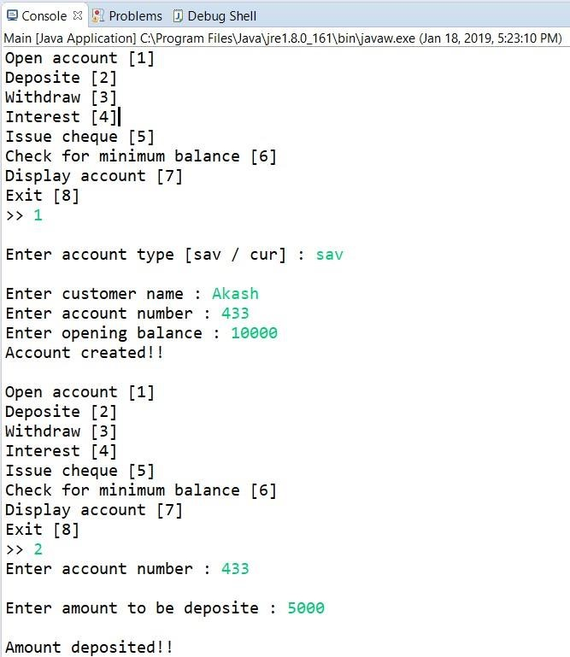

1. **Display the balance**

@Updated Balance Display

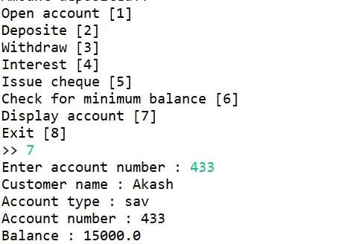

1. **Compute and deposit interest.**

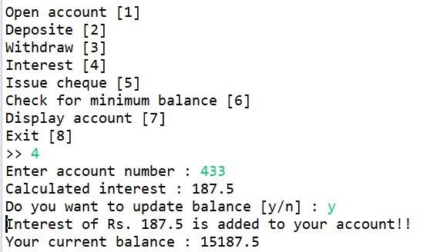

1. **Permit withdrawal and update the balance.**

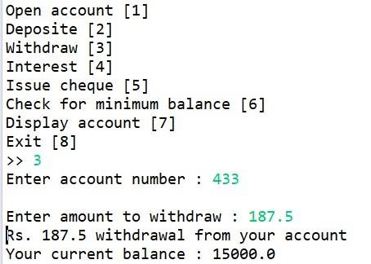

1. **Check for the minimum balance, impose penalty if necessary, and update the balance.**

**//Current Account is created and minimum balance is checked and fine is imposed**

